**Nesty Galoso**

**Student ID: 2354082**

Project Title: eLearning/ Learning Management System

# Deliverable 1 Cyber Security

1. **Project Scope**

**Users:**

* + **Students**: Enroll in courses, access learning materials, complete assignments, and participate in assessments.
  + **Instructors**: Create and manage course content, assignments, and assessments; interact with students, provide feedback, and monitor progress.
  + **Administrators**: Manage platform, users, courses, and configurations; provide technical assistance and maintain the platform.

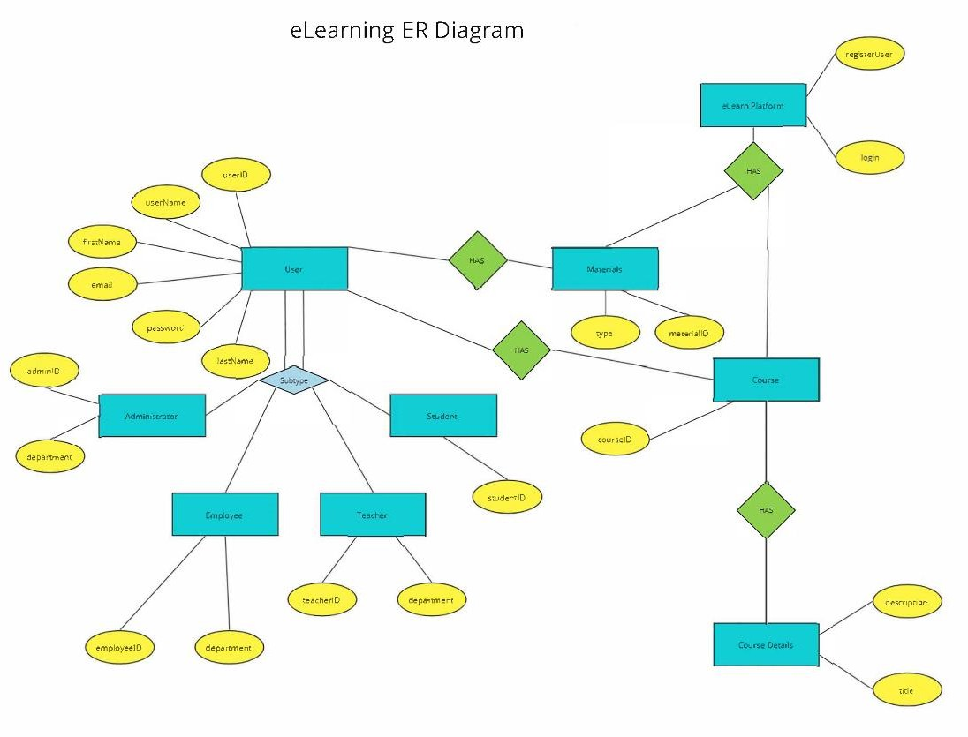

**Beneficiaries:**

* + **Educational Institutions**: Schools, colleges, and universities can use this platform to offer online courses and manage student progress.
  + **Corporations**: Businesses can use the platform for employee training and development programs.
  + **Individual Educators**: Tutors and trainers can create and manage their online courses.

**Potential Clients:**

* + **Coursera**
  + **Udemy**
  + **edX**
  + **Khan Academy**
  + **LinkedIn Learn**

**Class Diagram**

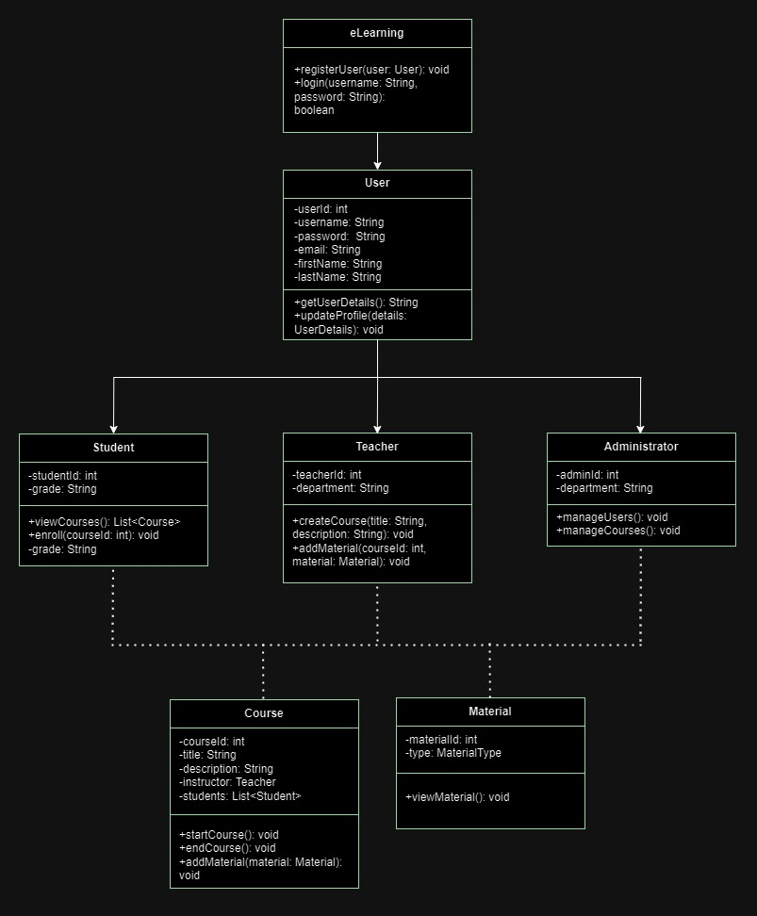

# Project Functionalities

**User Interface**

* + **Login Interface**: Users log in with credentials; system validates against the database.
    - **Screenshot**: Login Page

As the user opens the application, this Login screen opens where they can put in their credentials such as username and password.

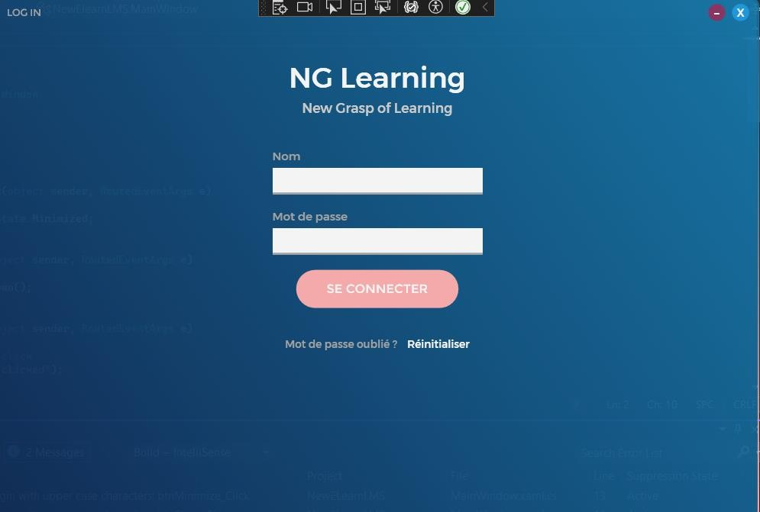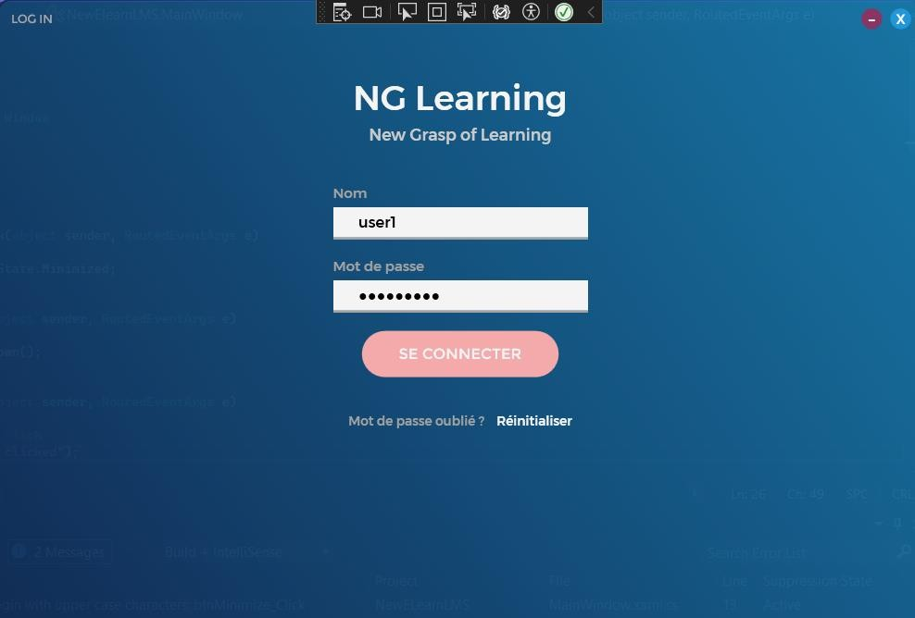

Once the user correctly provide their credentials and clicks **Log in**, Login successful popup/ prompt spears on the screen.

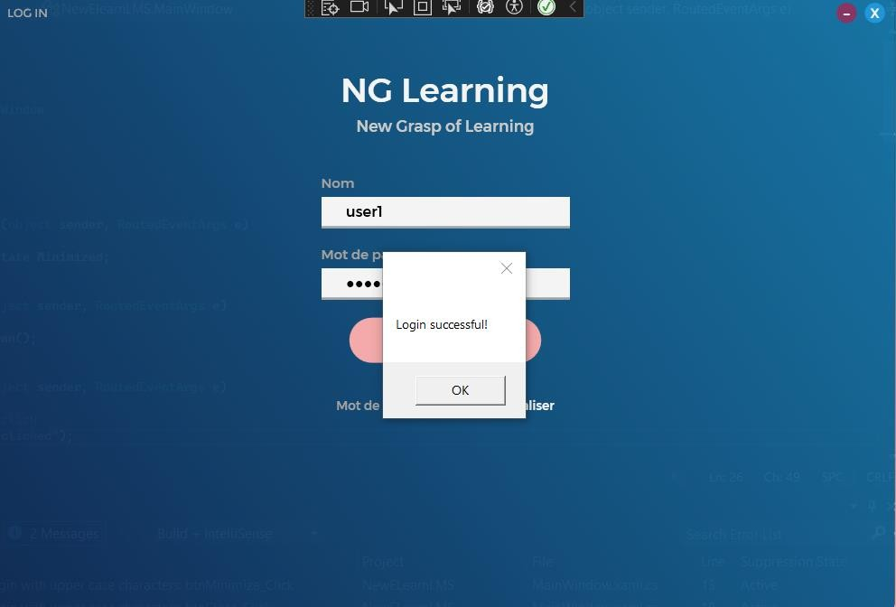

* + **Main Window**: Tabs for Home, Courses, and Messages.
    - **Screenshot**: Home Page

After going through the login stage, the home page appears. This screen provides you access to various tabs such Home, Courses, and Messages.

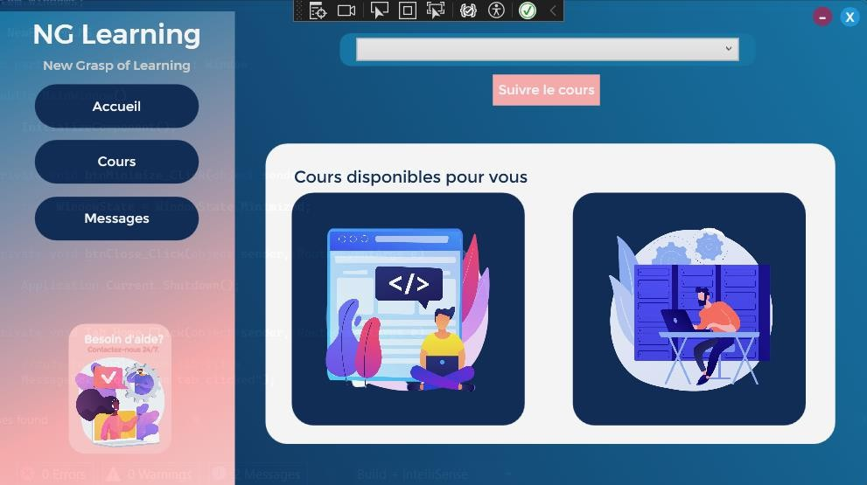

* **Course Selection Dropdown**: Users select courses from a dropdown list.
  + **Screenshot**: Course Selection

User can select courses on the drop-down menu, and click the Start Course button to proceed in completing the course whereon a popup/ prompt will show to notify the user.

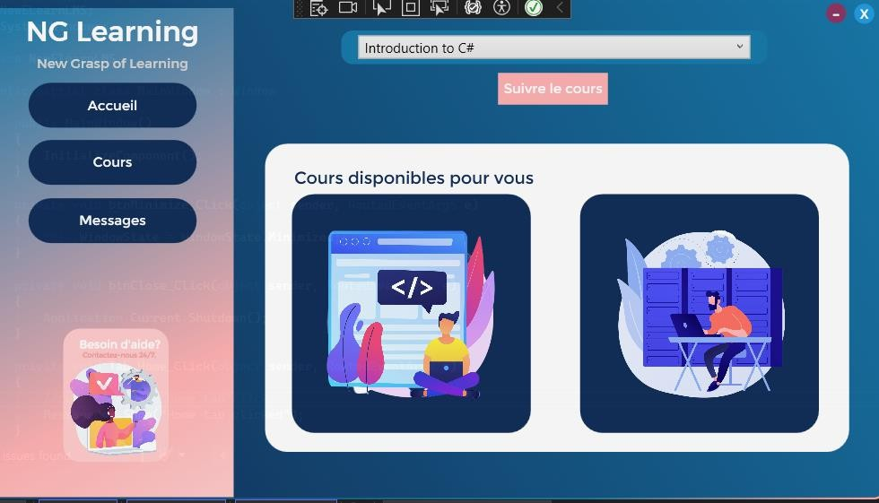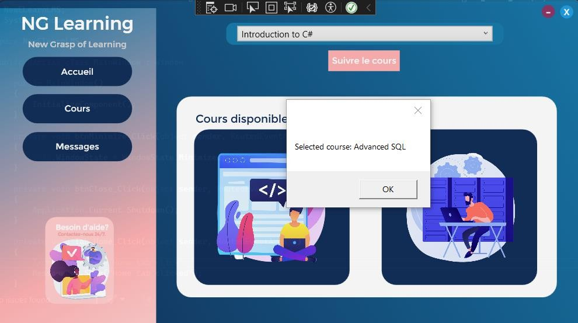

* + **Course Window**: Users select courses on the screen.
    - **Screenshot**: Course Selection

Aside from selecting courses on the Main Window, the users can also open courses on the Course window.

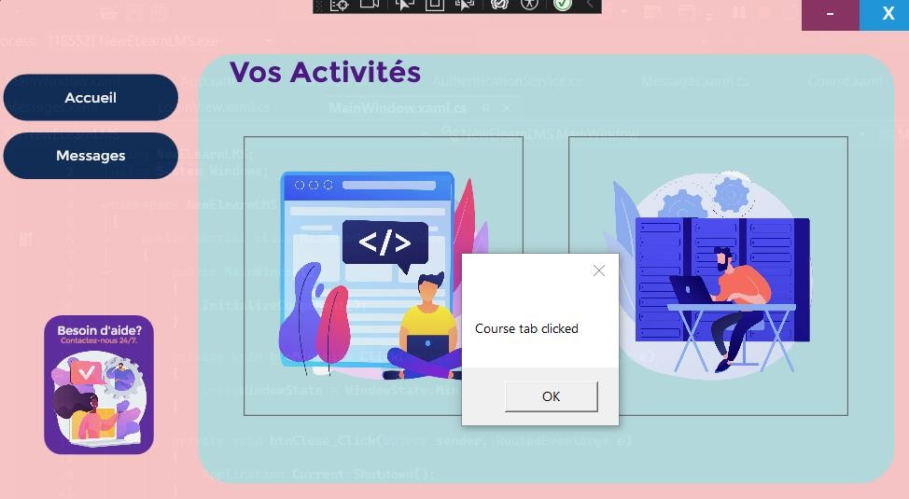

* + **Messages Window**: Users send and report possible bugs or issues.
    - **Screenshot**: Messages

As the user clicks the Messages button on the main window of the application, the Messages window opens where user can send out messages/ feedback.

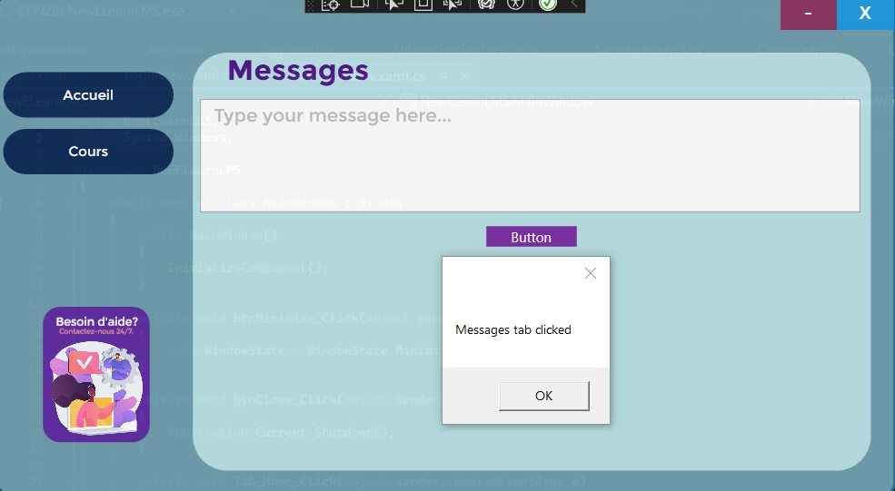

**Functionalities Implemented**

* + **LoginView**: Interface with username and password fields.
  + **Main Window**: Displays tabs for navigation.
  + **Messages**: Functions as a messaging board where users and admin can communicate for potentials issues and updates.
  + **Course Management**: Dropdown list for selecting courses.
    - **Course Creation**: Instructors create and manage courses, including multimedia content, assignments, quizzes, and forums.
    - **Course Enrollment**: Users can enroll in courses manually or via self-enrollment options.
    - **Course Calendar**: Displays important dates such as assignment deadlines and exam schedules.

**User Management**

* + **Roles and Permissions**: Define roles (e.g., student, teacher, admin) and set permissions.
  + **User Profiles**: Users create and manage profiles with personal and academic information.
  + **User Groups**: Group users for collaborative learning activities.

**Assessment Tools**

* + **Quizzes and Exams**: Create timed quizzes and exams with automated grading.
  + **Assignments**: Upload and manage assignment submissions with grading and feedback.
  + **Gradebook**: Track student performance across courses.

**Communication Tools**

* + **Forums and Chats**: Facilitate discussions and real-time communication among students and instructors.
  + **Messaging**: Private messaging system for direct communication.
  + **Announcements**: Send announcements about important updates and events.

**Tools Finalized**

* + **Visual Studio 2022**
  + **WPF Framework/.NET Framework 4.8**
  + **SQL Server 2019**

**Enhancements After Mid-Term Evaluation**

* + **User Management Interface**: Improved navigation and user experience.
  + **Course Calendar**: Added functionality to display important dates.
  + **Additional Assessment Tools**: Enhanced quiz and exam features.
  + **Performance Optimization**: Improved system responsiveness and load times.

# Project Setup

**Requirements:**

* + **Database**: Microsoft SQL Server 2019
  + **Development Environment**: Visual Studio 2022
  + **Framework**: .NET Framework 4.8
  + **REST API**: Snapshot and configuration for database connection

**Installation:**

1. **Install SQL Server 2019**: Set up the database and restore the provided backup.
2. **Install Visual Studio 2022**: Open the project solution.
3. **Configure REST API**: Update connection strings and API endpoints in the project settings.
4. **Run Locally**: Ensure all dependencies are installed, build the project, and start debugging.

# Work Progress in Future

**Future Enhancements:**

* + Rest API
  + **Mobile Application**: Develop a mobile version of the platform for accessibility on the go.
  + **Advanced Analytics**: Integrate machine learning algorithms to provide predictive analytics for student performance.
  + **Gamification**: Add gamification elements like badges and leaderboards to enhance user engagement.
  + **Virtual Classrooms**: Implement virtual classroom features with real-time video conferencing.
  + **Multilingual Support**: Provide support for multiple languages to cater to a global audience, specifically to cater to potential vendors and users based in the province of Quebec (French, and English users).
  + **Reporting and Analytics**:
    - **Activity Reports**: Track user activity, course participation, and resource usage.
    - **Performance Reports**: Generate reports on student performance and course completion rates.
    - **Custom Reports**: Create custom reports to meet specific needs.
  + **Integration and Extensibility:**
* **Plugins and Add-ons**: Support for various plugins to extend functionality.
* **APIs**: Provide APIs for integrating with third-party systems.
* **REST API Implementation:**
  + To ensure seamless integration and functionality, a REST API must be implemented for the eLearning platform. This API facilitates communication between the client application and the backend database, enabling various operations such as user authentication, course management, and data retrieval.
* **Unit Testing:**
  + Unit testing is crucial for verifying the functionality of individual components of the application. NUnit will be used to create and execute unit tests for the eLearning platform.
    1. Testing Framework: NUnit
    2. Key Components Tested:
       - Authentication: Tests to verify correct user authentication and token generation.
       - Course Management: Tests to ensure courses can be created, retrieved, updated, and deleted correctly.
       - User Management: Tests to confirm user-related operations such as adding, updating, and deleting users work as expected.
       - Assessment Management: Tests to verify the functionality of creating, retrieving, updating, and deleting assessments.
       - Data Validation: Tests to check that the data being processed meets the required validation rules and constraints.

**GitHub Link:**

[https://github.com/Desktop-App-Dev-Intl-Summer-2024/eLearning-Learning-Management-](https://github.com/Desktop-App-Dev-Intl-Summer-2024/eLearning-Learning-Management-System.git) [System.git](https://github.com/Desktop-App-Dev-Intl-Summer-2024/eLearning-Learning-Management-System.git)

<https://github.com/nestygaloso/NewELearnLMS.git>